|  |  |
| --- | --- |
| **Ex. No. 4** | RESPONSIVE WEBPAGE USING BOOTSTRAP UI FRAMEWORK |
| **Date of Exercise** | 08/08/2022 |
| **Web Host Link** |  |
| **Youtube Link** |  |

**Aim**

To create a responsive web design using Bootstrap UI framework.

**Description**

**Overview**

* Bootstrap is a free front-end framework for faster and easier web development
* Bootstrap includes HTML and CSS based design templates for typography, forms, buttons, tables, navigation, modals, image carousels and many other, as well as optional JavaScript plugins
* Bootstrap also gives you the ability to easily create responsive designs**.**

**What is Responsive Web Design?**

Responsive web design is about creating web sites which automatically adjust themselves to look good on all devices, from small phones to large desktops.

**Setting the Viewport**

To create a responsive website, add the following <meta> tag to all your web pages:

<meta name="viewport" content="width=device-width, initial-scale=1">

**Where to Get Bootstrap 5**

Include the following tag in order to integrate Bootstrap 5 Framework in your web design.

<!-- Latest compiled and minified CSS -->

<link href="https*://c*dn.jsdelivr.net*/*npm*/*bootstrap@5.1.3*/*dis*t/*css*/*bootstrap. min.css" rel="stylesheet">

<!-- Latest compiled JavaScript -->

<scriptsrc="https*://c*dn.jsdelivr.net*/npm/*bootstrap@5.1.*3/*dist*/j*s*/*bootstrap.bundle.min.js"><*/*script>

**Bootstrap 5 Containers**

Containers are used to pad the content inside of them, and there are two container classes available:

The .container class provides a responsive fixed width container

<div class="container">

<h1>My First Bootstrap Page<*/*h1>

<p>This is some text.</p>

<*/*div>

The .container-fluid class provides a full width container, spanning the entire width of the viewport

<div class="container-fluid">

<h1>My First Bootstrap Page<*/*h1>

<p>This is some text.<*/*p>

<*/*div>

**Bootstrap Spacing - Padding and Margin**

The classes are named using the format

{property}{sides}-{size} Where property is one of:

m - for classes that set margin

p - for classes that set padding

Where sides is one of:

t - for classes that set margin-top or padding-top

b - for classes that set margin-bottom or padding-bottom

S - for classes that set margin-left or padding-left

e- for classes that set margin-right or padding-right

x - for classes that set both *-left and *-right

y - for classes that set both *-top and *-bottom

blank - for classes that set a margin or padding on all 4 sides of the element.

**Responsive Images**

* The .rounded class adds rounded corners to an image.
* The .rounded-circle class shapes the image to a circle
* The .img-thumbnail class shapes the image to a thumbnail (bordered)

**Bootstrap tables**

* A basic Bootstrap table has a light padding and only horizontal dividers.
* The .table class adds basic styling to a table
* The .table-striped class adds zebra-stripes to a table
* The .table-bordered class adds borders on all sides of the table and cells
* The .table-hover class adds a hover effect (grey background color) on table rows
* The .table-dark class adds a black background to the table
* The .table-borderless class removes borders from the table

**Program :**

<!DOCTYPE html>

<!--Responsive Webpage Using Bootstrap UI Framework-->

<html lang="en">

  <head>

    <meta charset="UTF-8">

    <meta http-equiv="X-UA-Compatible" content="IE=edge">

    <meta name="viewport" content="width=device-width, initial-scale=1.0">

    <link rel="stylesheet" href="https://maxcdn.bootstrapcdn.com/bootstrap/3.4.1/css/bootstrap.min.css">

    <script src="https://ajax.googleapis.com/ajax/libs/jquery/3.6.0/jquery.min.js"></script>

    <script src="https://maxcdn.bootstrapcdn.com/bootstrap/3.4.1/js/bootstrap.min.js"></script>

    <title>Experiment-4</title>

    <style>

      .top{

        margin: 20px;

      }

      * {

        box-sizing: border-box;

        }

      .row {

        display: flex;

        margin-left:-5px;

        margin-right:-5px;

      }

      .column {

        flex: 50%;

        padding: 5px;;

      }

      .table-left

        {

          border: 1px solid black;

          border-collapse: collapse;

          padding: 6px;

          margin-left: 10px;

          border-color: #36e2f5;

          width: 75%;

          border-spacing: 5px;

      }

      td{

        padding: 6px;

        width: 5px;

      }

    </style>

  </head>

  <body>

    <div class="top">

      <img src = "omega logo.png" width="100" height="100" align="left">

        <div class=" bg-light align-middle text-right ">

        <button type ="button" class="'btn btn-link"">Home</button>

        <button type ="button" class="'btn btn-link">Service</button>

        <button type ="button" class="'btn btn-link">Clients</button>

        <button type ="button" class="'btn btn-link">Contact Us</button>

        <button type ="button" class="'btn btn-link ">Login/Sign Up</button>

        <input type="text" placeholder="Search Here...">

        <button type ="button" class="'btn btn-primary " >submit</button>

        </div>

    </div><br><br>

    <div id="myCarousel" class="carousel slide" data-ride="carousel">

      <!-- Indicators -->

      <ol class="carousel-indicators">

        <li data-target="#myCarousel" data-slide-to="0" class="active"></li>

        <li data-target="#myCarousel" data-slide-to="1"></li>

        <li data-target="#myCarousel" data-slide-to="2"></li>

      </ol>

      <!-- Wrapper for slides -->

      <div class="carousel-inner">

        <div class="item active">

          <img src="photo1.jpg" alt="Los Angeles">

        </div>

        <div class="item">

          <img src="photo2.jpeg" alt="Chicago">

        </div>

      </div>

      <!-- Left and right controls -->

      <a class="left carousel-control" href="#myCarousel" data-slide="prev">

        <span class="glyphicon glyphicon-chevron-left"></span>

        <span class="sr-only">Previous</span>

      </a>

      <a class="right carousel-control" href="#myCarousel" data-slide="next">

        <span class="glyphicon glyphicon-chevron-right"></span>

        <span class="sr-only">Next</span>

      </a>

    </div><br>

    <div class="row">

      <div class="column">

        <table class="table-left">

          <tr>

            <td colspan="4" align="center"><h1 class="text-primary" >Registration Form</h1></td>

          </tr>

          <tr>

              <td colspan="2">Email</td>

              <td colspan="2">Password</td>

          </tr>

          <tr>

              <td colspan="2"><input type="email" size="25"></td>

              <td colspan="2"><input type="password" size="25"></td>

          </tr>

          <tr>

              <td colspan="4">Address</td>

          </tr>

          <tr>

            <td colspan="4"><input type="text" placeholder="1234 Main St" size="57"></td>

          </tr>

          <tr>

            <td colspan="4">Address 2</td>

          </tr>

          <tr>

            <td colspan="4"><input type="text" placeholder="Apartment, studio or floor" size="57"></td>

          </tr>

          <tr>

            <td colspan="2">City</td>

            <td>State</td>

            <td>Zip</td>

          </tr>

          <tr>

            <td colspan="2"><input type="text" size="25"></td>

            <td> <select name="cars" id="cars">

              <option>Tamil Nadu</option>

              <option>Kerala</option>

              <option>Andhra Pradesh</option>

              <option>Delhi</option>

              </select></td>

            <td><input type="text" size="6"></td>

          </tr>

          <tr>

            <td colspan="4"><input type="checkbox">Check me out</td>

          </tr>

          <tr>

            <td colspan="4"><button type ="button" class="'btn btn-primary">Sign in</button></td>

          </tr>

        </table>

      </div>

      <div class="column">

        <table class="table table-bordered" style="border-color:ash ;" >

          <tr class="bg-primary" >

            <th>S.No</th>

            <th>Reg. No</th>

            <th>Name of the Participant</th>

            <th>Collaborative activity</th>

            <th>Collaborating agency</th>

          </tr>

          <tr>

            <td>1</td>

            <td>UR16AE001</td>

            <td>ANIT ANU JOHN</td>

            <td>Product Design and Analysis</td>

            <td>CADD Centre</td>

          </tr>

          <tr>

            <td>2</td>

            <td>UR16AE011</td>

            <td>VASANTHA KANESH M</td>

            <td>Product Design and Analysis</td>

            <td>CADD Centre</td>

          </tr>

          <tr>

            <td>3</td>

            <td>UR16AE013</td>

            <td>PRIYA PRAKASH</td>

            <td>Product Design and Analysis</td>

            <td>CADD Centre</td>

          </tr>

          <tr>

            <td>4</td>

            <td>HARRISH</td>

            <td>JEBIN JOHN J</td>

            <td>Product Design and Analysis</td>

            <td>CADD Centre</td>

          </tr>

          <tr>

            <td>5</td>

            <td>UR16AE018</td>

            <td>DONALD DOLI</td>

            <td>Product Design and Analysis</td>

            <td>CADD Centre</td>

          </tr>

          <tr>

            <td>6</td>

            <td>UR16AE020</td>

            <td>J P GOKUL</td>

            <td>Product Design and Analysis</td>

            <td>CADD Centre</td>

          </tr>

          <tr>

            <td>7</td>

            <td>UR16AE021</td>

            <td>JEROME TASON</td>

            <td>Product Design and Analysis</td>

            <td>CADD Centre</td>

          </tr>

          <tr>

            <td>8</td>

            <td>UR16AE022</td>

            <td>AFNAN M. ARIEF</td>

            <td>Product Design and Analysis</td>

            <td>CADD Centre</td>

          </tr>

        </table>

      </div>

    </div>

  </body>

</html>

**Output :**

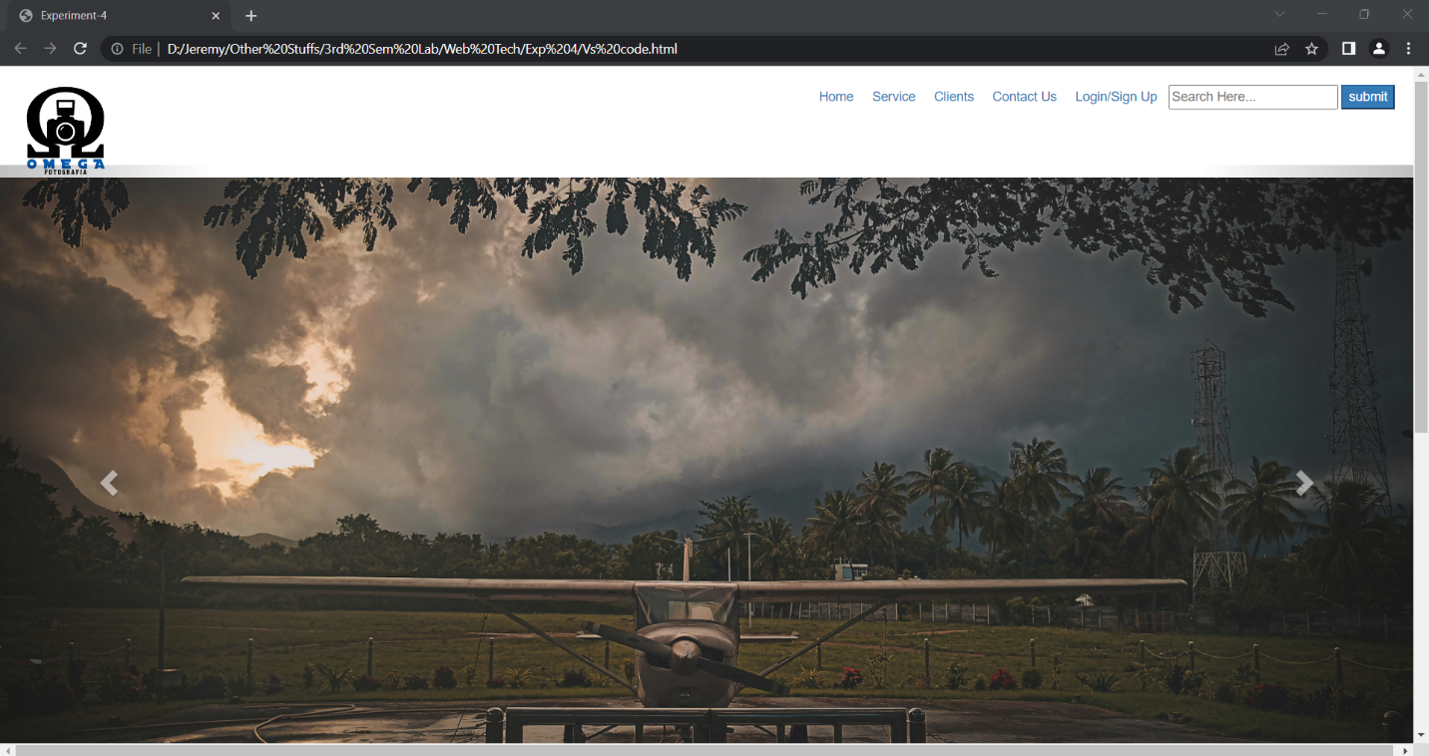

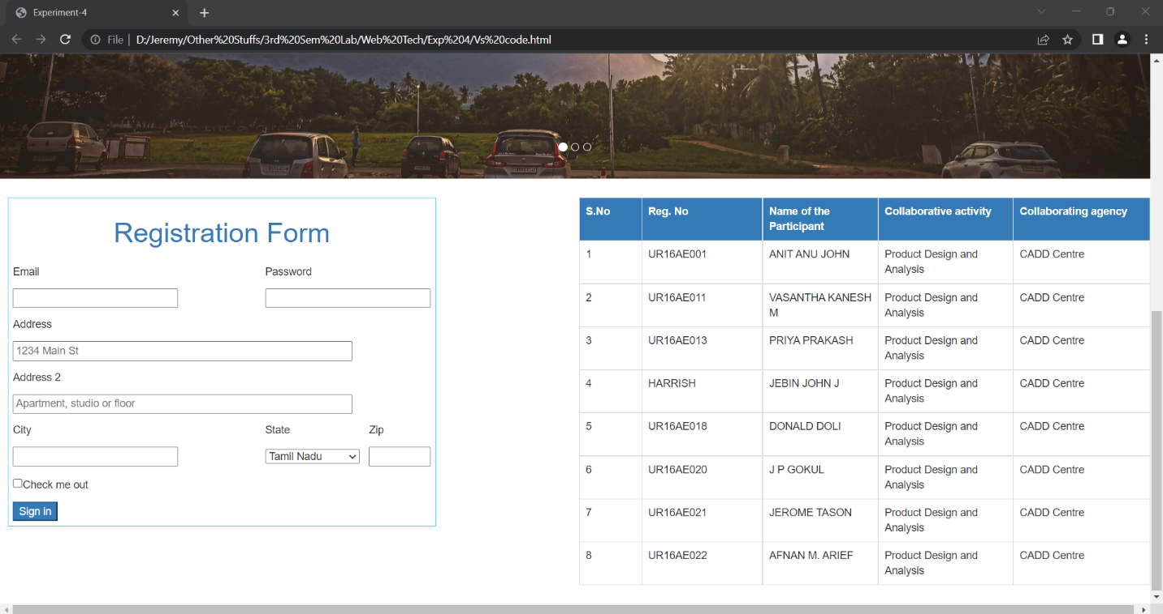

**Result :**

The given program is coded and executed successfully.